Project Proposal

**Question/needs:**

Distributed of denial of service attacks is huge threat to network security and create to aim huge disturbance in the network with malicious traffic. Although many statistical methods have been designed for Distributed of denial of service attack detection, designing a real-time detector with low computational overhead is still one of the main concerns. On the other hand, the evaluation of new detection algorithms and techniques heavily relies on the existence of well-designed datasets. It can exploit attacks in many different ways, an image below shows bright idea on how these attacks occurs:

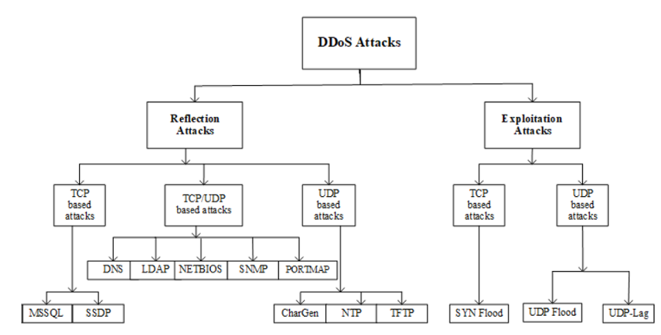

Working in building this model will be huge benefit in preventing the above attacks. I managed in obtaining after long research in which illustrate benign attacks and most up to date DDos attacks in which help create this model.

**Data description:**

Dataset I obtained was from UNB <https://www.unb.ca/cic/datasets/ddos-2019.html> in which the data have been obtained from using tool analysis that was used to analysis network traffic attacks. It was used to generate bidirectional flows, where the first packet determines the forward (source to destination) and backward (destination to source) directions, hence more than 80 statistical network traffic features such as Duration, Number of packets, Number of bytes, Length of packets, etc. can be calculated separately in the forward and backward directions. I am planning to use deep learning model such LSTM, RNN and transformer as after study it turned out to be good source for prediction. I will plan to conduct this model in which differentiate between benign and DDos attacks.

**Tools:**

I will be planning to use deep learning model and library. I will be using keras, PCA, pandas and numpy library for visualization and calculation. On top of my head those are the tools I can think of. However, going through the model I will come up with mode approaches.

#### MVP Goal:

#### The goal of this project is to better understand which attacks can cause DDos and which attacks are benign. A visual image below provides better idea.

#### 

#### This visual image shows the different between the normal and abnormal attack. The far right of the image shows the normal traffic while the far left near 0.7 shows the abnormal attacks look likes. I use this simple plot on dataset to give an idea how normal traffic vs abnormal traffic are. Using deep learning will help us find out the targeted traffic.